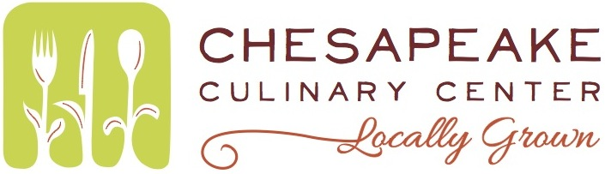
Literary Events
Matinee/Dinner
Sophie Kerr

Passed Appetizers (on arrival)
Crab balls, remoulade Sauce
Vegetable “Shooters”w/ hummus (Vegan,GF)

Buffet
Fall Salad (all toppings on side)
Fresh greens, dried cranberries, feta, diced apple sunflower seeds, basil balsamic vinaigrette
Cornbread & Biscuits(beaten?) GF Roll option, Butter
Fried Chicken
Herb roasted Chicken
Macaroni & Cheese
Mashed Potatoes
Chick pea salad (Vegan,GF)
Roasted fall vegetables, balsamic reduction

Assorted Seasonal Desserts
Water, Unsweetened tea, regular and decaf coffee

